ADVENTURES IN 3 DIMENSIONS: 20TH CENTURY SCULPTURE IN BRITAIN

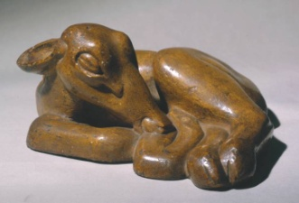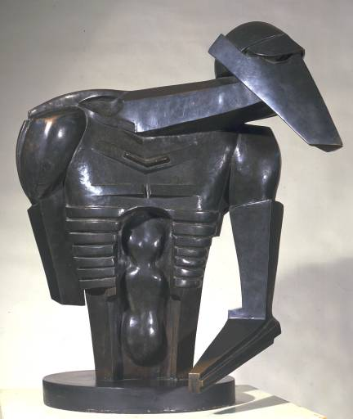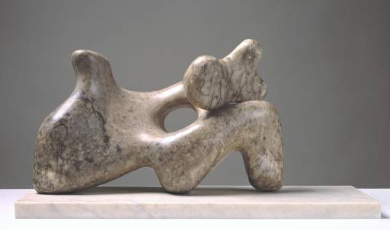

I became a sculptor to make things real. (Henry Moore)

Modern sculpture is mysterious to many people. Frequently abstract or distorted in form, and complicated rather than illuminated by critical jargon, it seems difficult and inaccessible. Yet everywhere we go, sculpture is: invading our space, demanding to have attention paid. That is what makes it so challenging, and potentially so rewarding.
The story of sculpture through the 20th century reveals a growing understanding of how form can be manipulated to explore emotion as well as appearance, how materials can dictate meaning as well as shape, and how technical skill and concentrated imagination can use a three-dimensional language as expressively as any painter, poet or novelist to give us insights into the rhythms and meanings of life itself.
Initially controversial, the names of the sculptors involved have tended to become more accessible than what they made. Jacob Epstein and Henri Gaudier-Brzeska; Barbara Hepworth and Henry Moore; Michael Ayrton, Anthony Gormley, Elisabeth Frink and Eduardo Paolozzi – their work stands at the heart of our time, and yet still, too often, people looking at individual pieces are intimidated where they should be enthralled. The viewing of sculpture is an exploration, an adventure, something to be enjoyed. This lecture sets out to prove that we can all be explorers.

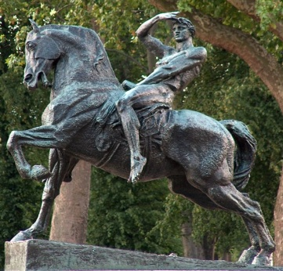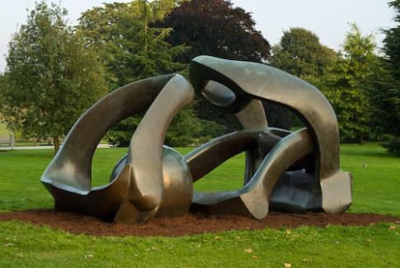

Illustrations:
Henri Gaudier-Brzeska Sleeping Fawn 1913
Jacob Epstein Rock Drill Torso 1913-16
Barbara Hepworth Mother and Child 1934
George Frederic Watts: Physical Energy 1902
Henry Moore Hill Arches 1972

ARTISTS

Alfred Gilbert 1854-1934
Frederic Leighton 1830-96
Hamo Thorneycroft 1850-1925
George Frederic Watts 1817-1904

Jacob Epstein 1880-1959
Frank Dobson 1888-1963
Alan Durst 1883-1970
Henri Gaudier-Brzeska 1891-1915
Eric Gill 1882-1986

Michael Ayrton 1921-75
Anthony Caro 1924-2013
Elisabeth Frink 1930-93
Barbara Hepworth 1903-75
Henry Moore 1898-1986
Eduardo Paolozzi 1924-2005

Tony Cragg b.1949
Antony Gormley b.1950
Anish Kapoor b.1954
David Nash b.1945

FURTHER READING
Susan Beattie The New Sculpture 1983 Yale University Press
Penelope Curtis Sculpture 1900-1945 (Oxford History of Art) 1999
Oxford University Press
Penelope Curtis & Keith Wilson Modern British Sculpture 2011 Royal Academy
Herbert George The Elements of Sculpture 2014 Phaidon
D.J. Getsey Sculpture and the Pursuit of a Modern Ideal in Britain
Ashgate Publishing 2004
William Tucker The Language of Sculpture (new ed.) Thames & Hudson 1992

There is also an excellent series published by Lund Humphries in association with the Henry Moore Foundation: British Sculptors and Sculpture, which includes monographs of many less familiar artists.

FURTHER EXPLORATIONS
There is an increasing number of Sculpture Parks in this country which provide opportunities to see sculpture in what many of the makers regarded as its natural habitat – the landscape. Among the best are:
- The Barbara Hepworth Museum and Sculpture Garden, St Ives, Cornwall
- The Cass Sculpture Foundation, Goodwood.
- The Henry Moore Foundation, Perry Green, Hertfordshire
- The Ironbridge Open Air Museum of Steel Sculpture, Telford, Shropshire
- The New Art Centre Sculpture Park and Gallery, Roche Court, Wiltshire
- Sausmarez Manor Art Park, Guernsey
- The Yorkshire Sculpture Park, Wakefield

And in addition – keep your eyes open wherever you go. City, town and country – there’s more sculpture out there than you might think!
SLIDE LIST
Slide 1: (from left)
Eric Gill Ecstasy 1911 (Portland stone) [Tate Gallery]
Michael Ayrton Scavenger II 1968 (bronze) [Private Collection (pc)]
Henry Moore Hill Arches 1972-3 (bronze) [Moore Foundation]

Slide 2:
Elisabeth Frink Walking Madonna 1981 (bronze) [Salisbury Cathedral]
Hamo Thorneycroft Oliver Cromwell 1895-99 (bronze) [Houses of Parliament]

Slide 3:
Frederic Leighton Athlete Wrestling with a Python 1877 (bronze)
[Tate Gallery (TG)]
George Frederic Watts Physical Energy 1902 (bronze) [Kensington Gardens]

Slide 4:
Alfred Gilbert Perseus Arming 1882 (bronze) [Minneapolis]
George Frampton Peter Pan 1912 (bronze) [Kensington Gardens]

Slide 5:
Alfred Gilbert Shaftsbury Memorial (Eros) 1886-93 (bronze & aluminium)
Thomas Brock A Moment of Peril 1881 (bronze) [Leighton House garden]

Slide 6:
Hamo Thorneycroft Joy of Life 1895 (bronze) [pc]
Eric Gill A Roland for an Oliver 1910 (Hoptonwood stone) [University of Hull]

Slide 7: (from left)
Jacob Epstein Infancy 1908 (plaster model for stone)
[Original carvings on Zimbabwe House, The Strand]
Portrait of Einstein 1933 (bronze) [V&A]
Consummatum Est 1936-7 (alabaster)
[National Gallery of Scotland, Edinburgh]

Slide 8: (from left)
Henri Gaudier-Brzeska Hieratic Head of Ezra Pound 1914 (marble)
[National Gallery of Art, Washington DC]
Sleeping Fawn 1913 (painted plaster from original marble) [TG]
Bird Swallowing Fish 1914 (painted plaster) [Kettle’s Yard, Cambridge]

Slide 9:
Alan Durst The Acrobats 1937 (wood) [TG]
Frank Dobson Manchild 1921 (marble) [TG]

Slide 10:
Jacob Epstein Rock Drill (Torso) 1913-16 (bronze) [TG]
Henry Moore Large Upright Internal/External Form 1981-2 (bronze) [Kew]

Slide 11: (from left)
Henry Moore King and Queen 1952-3 (bronze) [Glenkiln Estate, Dumfries]
A Suckling Child 1930 (alabaster) [Pallant House, Chichester] Stringed Figure 1958-60 (bronze & strings) [TG]

Slide 12:
Henry Moore Reclining Figure 1936 (elm) [Wakefield Art Gallery]
Barbara Hepworth Mother and child 1934 (Cumberland alabaster) [TG]

Slide 13: (from top left)
Barbara Hepworth Conoid, Sphere and Hollow III 1937 (marble)
[Government collection (HM Treasury)]
Single Form (September) 1961 (walnut) [TG]
Stringed Figure (Curlew II) 1956 (bronze & strings) [TG]

Slide 14:
Anthony Caro Early One Morning 1962 (painted steel & aluminium) [TG]

Slide 15: (from top left)
Elisabeth Frink Bird 1952 (bronze) [TG]
Riace Figures 1986-9 (bronze) [Yorkshire Sculpture Park]
Prisoner 1988 (bronze) [Bristol City Museum]

Slide 16:
Eduardo Paolozzi Cyclops 1957 (bronze) [TG]
Michael Ayrton Arkville Minotaur 1968-9 (bronze) [London Wall, Barbican]

Slide 17:
Antony Gormley Quantum Cloud 2000 (steel) [River Thames, Greenwich]
Anish Kapoor & Cecil Balmond Orbit 2012 [Olympic Park, Stratford]

Slide 18: (from left)
Tony Cragg Here Today, Gone Tomorrow 2002 (stone)
[Cass Sculpture Foundation, Goodwood]
David Nash Black Dome 1986 (charred oak) [Forest of Dean, Glos.]
Wooden Boulder 1978-2003-2009-? (oak)
[River Dwyryd and estuary, N. Wales]

Slide 19:
Jacob Epstein Jacob and the Angel 1940-41 (alabaster) [TG]
Antony Gormley Angel of the North 1995-8 (steel & concrete) [Gateshead]

Slide 20:
Barbara Hepworth Conversation with Magic Stones 1973 (bronze) [TG]

My sculpture is sufficient explanation in itself. (Jacob Epstein)

A sculpture might, and sculptures do, reside in emptiness, but nothing happens
until the living human encounters the image. (Barbara Hepworth)

Art is an instrument for thinking. (Antony Gormley)

